Resident survey results (Jan-Feb 2013)

In Jan-Feb 2013 the Public Health Physicians of Canada (PHPC) Resident Council conducted a survey of the Public Health & Preventive Medicine (PH&PM) residents. The Public Health Physicians of Canada has been experiencing a shortfall of funds and was exploring potential avenues for revenue generation, including increasing membership fees for the full members and introducing a membership fee for the residents.
Objectives
The main objective was to assess the PH&PC resident’s willingness and ability to pay a membership fee. Additional objectives were to evaluate PH&PC residents’ knowledge of and satisfaction on the services received from the resident council and PHPC council.
Methods
A survey was created using Survey Monkey. There were 9 questions in the survey, including information about the residency program and postgraduate training year, as well questions on the PHPC and resident council services, willingness to pay a membership fee, etc. An open ended question was also including seeking additional feedback to improve the resident council work. The survey was also translated to French to facilitate participation of French speaking residents. The survey link was distributed by resident representatives to all 14 PH&PM residency programs across Canada.
Results
66 residents from 13 residency programs completed the survey (Table 1). There were no respondents from the Université de Montreal. 64 residents provided information on the university of PH&PM residency program. The largest number of respondents (13 residents) was from the University of Toronto and University of Calgary (12 residents).
Of 60 residents, which provided information on the postgraduate year of training, 23% were in their first year of PH&PM residency training and15% were in their 5-th year (Figure 1).
Table 1. Count and proportion of the respondents by university
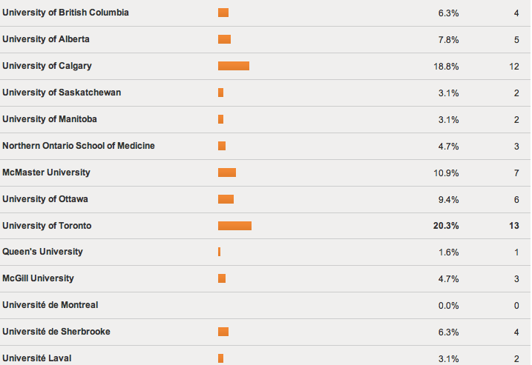

Figure 1. Distribution of the residents by year of training.

Of 66 residents, 50 (76%) were self-identified as current members of PHPC. Most residents were aware of the PHPC website, however, less than half ever used it (Figure 2). Only 15 respondents ever attended CPHA events organized by PHPC. Hot topics repository was the least popular among the respondents; only 5 residents ever used it.
Figure 2. Knowledge on and use of PHPC services

One third of the respondents (21 residents) did not receive regular emails from the PHPC resident council. The majority of the residents who received regular emails from the resident council found them to be “always” (19%) or “sometimes” (72%) helpful.
Thirteen residents provided suggestions/ feedback for the resident council. Most common feedback was related to the Royal College Exam, such as exam preparation (e.g. collaboration for compiling CMAJ and CJPH public health relevant articles), advocacy for clear Royal College Exam objectives (Table 2). Other suggestions included creating mentorship opportunities, informing about elective opportunities, organizing PHPC resident events, increasing the frequency of the updates from the council, sharing the minutes, increasing the support of the resident council from the PHPC, etc.

Table 2. Suggestions for the Resident Council
 | Number of respondents | %
Exam preparation | 3 | 23
Advocacy for clear Royal College Exam Objective | 2 | 15
Networking opportunities | 2 | 15
Career issues | 4 | 31

About one third of the residents (31%) would be willing to pay membership fees, 34% did not agree to pay the fees and 35% were not sure. 29 residents (58%) would be would pay maximum $25 if needed, 18 residents (36%) would pay $50 and 3 residents (6%) would pay maximum $75. The most common reasons for disagreeing to pay membership fees were additional financial burden that would be imposed by the membership fee and the perception that the fee is not justified given the services they receive.

